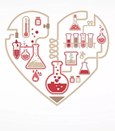
Working Scientifically Progression
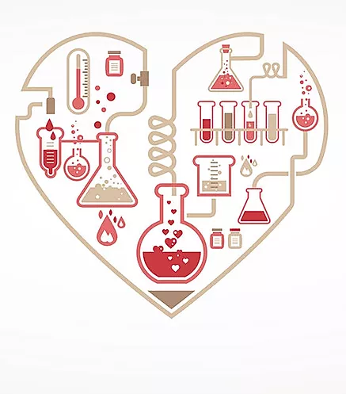

EYFS
Plan | - show curiosity about objects, events and people  - questions why things happen  -engage in open-ended activity  -take a risk, engage in new experiences and learn by trial and error
Do | -find ways to solve problems / find new ways to do things / test their ideas  -develop ideas of grouping, sequences, cause and effect  -know about similarities and differences in relation to places, objects, materials and living things  -comments and asks questions about aspects of their familiar world such as the place where they live or the natural world  -closely observes what animals, people and vehicles do  -use senses to explore the world around them  -choose the resources they need for their chosen activities  -handle equipment and tools effectively  -make links and notice patterns in their experience  -create simple representations of events, people and objects  -develop their own narratives and explanations by connecting ideas or events  -builds up vocabulary that reflects the breadth of their experience
Review | -answer how and why questions about their experiences  -make observations of animals and plants and explain why some things occur, and talk about changes

 |  |  | KS1 |  | Lower KS2 |  | Upper KS2
 |  |  | Y1 | Y2 | Y3 | Y4 | Y5 | Y6
WORKING SCIENTIFICALLY | PLAN | Planning | • asking simple questions and recognising that they can be answered in different ways |  | • asking relevant questions and using different types of scientific enquiries to answer them  • setting up simple practical enquiries, comparative and fair tests |  | • planning different types of scientific enquiries to answer questions, including recognising and controlling variables where necessary
WORKING SCIENTIFICALLY | DO | Observing / obtaining evidence | • observing closely, using simple equipment  • performing simple tests  • identifying and classifying |  | • making systematic and careful observations and where appropriate, taking accurate measurements using standard units, using a range of equipment, including thermometers and data loggers |  | • taking measurements, using a range of scientific equipment, with increasing accuracy and precision, taking repeat readings where appropriate
WORKING SCIENTIFICALLY | DO | Recording | • gathering and recording data to help in answering questions |  | • gathering, recording, classifying and presenting data in a variety of ways to help in answering questions  • recording findings using simple scientific language, drawings, labelled diagrams, keys, bar charts, and tables |  | • recording data and results of increasing complexity using scientific diagrams and labels, classification keys, tables, scatter graphs, bar and line graphs
WORKING SCIENTIFICALLY | REVIEW | Concluding | • using their observations and ideas to suggest answers to questions |  | • reporting on findings from enquiries, including oral and written explanations, displays or presentations of results and conclusions  • identifying differences, similarities or changes related to simple scientific ideas and processes  • Using straightforward scientific evidence to answer questions or to support their findings |  | • reporting and presenting findings from enquiries, including conclusions, causal relationships and explanations of and degree of trust in results, in oral and written forms such as displays and other presentations.
WORKING SCIENTIFICALLY | REVIEW | Evaluating |  |  | •using results to draw simple conclusions, make predictions for new values, suggest improvements and raise further questions. |  | • using test results to make predictions to set up further comparative and fair tests.  • identifying scientific evidence that has been used to support or refute ideas or arguments

Working scientifically can be assessed using TAPS focused Assessment found at:
https://pstt.org.uk/application/files/3814/7014/6302/Overview_of_TAPS_Focused_Assessment_plans.pdf

