Sacred Heart RC Nursery & Primary School

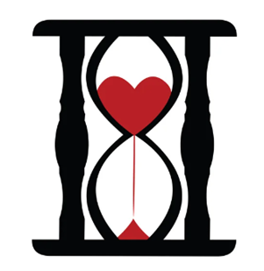

Progression in Science
Including Early Years Foundation age

Progression in Design and Technology
Progression in History
Including Early Years Foundation Stage

Last updated: 6/6/22 TD / 5.3.23 ND

EYFS
Understanding the world involves guiding children to make sense of their physical world and their community. The frequency and range of children’s personal experiences increases their knowledge and sense of the world around them – from visiting parks, libraries and museums to meeting important members of society such as police officers, nurses and firefighters. In addition, listening to a broad selection of stories, non-fiction, rhymes and poems will foster their understanding of our culturally, socially, technologically and ecologically diverse world. As well as building important knowledge, this extends their familiarity with words that support understanding across domains. Enriching and widening children’s vocabulary will support later reading comprehension.
EYFS | Birth to 3 | 3 to 4 year olds | Reception | Early Learning Goal
Understanding the World | Make connections between the features of their family and other families. | Begin to make sense of their own life-story and family’s history. | Comment on images of familiar situations in the past. | Know some similarities and differences between things in the past and now, drawing on their experiences and what has been read in class.  Understand the past through settings, characters and events encountered in books read in class and storytelling.
What adults can do to support this | Be open to children talking about differences and what they notice. For example, when children ask questions like: “Why do you wear a scarf around your head?” or “How come your hair feels different to mine?” Point out the similarities between different families, as well as discussing differences. | Spend time with children talking about photos and memories. Encourage children to retell what their parents told them about their life story and family.  Present children with pictures, stories, artefacts and accounts from the past, explaining similarities and differences. Offer hands-on experiences that deepen children’s understanding, such as visiting a local area that has historical importance. Show images of familiar situations in the past, such as homes, schools, and transport. Look for opportunities to observe children talking about experiences that are familiar to them and how these may have differed in the past. Offer opportunities for children to begin to organise events using basic chronology, recognising that things happened before they were born. | Present children with pictures, stories, artefacts and accounts from the past, explaining similarities and differences. Offer hands-on experiences that deepen children’s understanding, such as visiting a local area that has historical importance. Show images of familiar situations in the past, such as homes, schools, and transport. Look for opportunities to observe children talking about experiences that are familiar to them and how these may have differed in the past. Offer opportunities for children to begin to organise events using basic chronology, recognising that things happened before they were born.
The National Curriculum for History (2014) aims to ensure that all pupils:
- Know and understand the history of these islands as a coherent, chronological narrative, from the earliest times to the present day: how people’s lives have shaped this nation and how Britain has influenced and been influenced by the wider world
- Know and understand significant aspects of the history of the wider world: the nature of ancient civilizations; the expansion and dissolution of empires; characteristic features of past non-European societies; achievements and follies of mankind
- Gain and deploy a historically-grounded understanding of abstract terms such as ‘empire’, ‘civilization’, ‘parliament’, and ‘peasantry’
- Understand historical concepts such as continuity and change, cause and consequence, similarity, difference and significance, and use them to make connections, draw contrasts, analyse trends, frame historically-valid questions and create their own structured accounts, including written narratives and analyses (organization and communication)
- Understand the methods of historical enquiry, including how evidence is used rigorously to make historical claims and discern how and why contrasting arguments and interpretations of the past have been constructed
- Gain historical perspective by placing their growing knowledge into different contexts, understanding the connections between local, regional, national and international history; between cultural, economic, military, political, religious and social history and between short and long-term timescales
Disciplinary concepts/2nd order concepts (skills of a historian) are in bold. Please use these in your LOs
Examples and case studies throughout to help with planning for progression and assessment
KS1 & KS2
Key Concept - Chronological Understanding
Year 1 | Changes within living memory. Where appropriate, these should be used to reveal aspects of change in national life  Toys (Include family trees & familiar things old and new including toys) Setting up a toy museum  Local link: Visit to care home, visit from museum  Significant historical events, people and places in their own locality  Arthur Hyde Dendy & George Bridgman - Paignton Pier, Oldway and local road names  Holidays now, contrasted with holidays in the past  Local Link: beaches, pier, Oldway Mansion  Use timeline to show children when events took place  Learning Objectives:  - Sequence events or up to three related objects in chronological order  - Sequence stories from memory and personal memories
 | Key Concept - Range and Depth of Historical Knowledge
Significant historical events, people and places in their own locality | Substantive Concepts to be covered:  - Culture & Society (to include social class, childhood)  - Leisure & Entertainment
Changes within living memory. Where appropriate, these should be used to reveal aspects of change in national life | Substantive Concepts to be covered:  - Culture & Society (to include social class, childhood and jobs)  - Leisure & Entertainment  - Costume  - Travel & Transport  - Architecture & Buildings  - Settlements & Homes  - Trade & Industry
Key concept:  Continuity & Change (in & between periods) | Learning Objectives:  - To tell the difference between past and present in their own and other people’s lives. Listen to eye-witness accounts from grandparents/older adults in the community - recognize, identify
Key Concept:  Causes & Consequences | Learning Objectives:  - To recognize why people did things, why events happened and what happened as a result
Key Concept:  Similarities & Differences (within a period/  situation) | Learning Objectives:  - To begin to suggest why something might be different – e.g. begin to describe similarities and differences in artefacts – reason, hypothesize, observe  - To begin to use a range of sources to find out characteristic features of the past  - To make simple observations about different types of people, events, beliefs within a society – compare & contrast, categorize/classify, select
Key Concept:  Significance (of events/people) | Learning Objectives:  - Talk about people and places and why they are important
 | Key Concept - Historical Interpretation
Learning Objectives:

- To look at books, videos, photographs, pictures and artefacts to find out about the past

 | Key Concept - Historical Enquiry
Learning Objectives:

- To identify different ways in which the past is represented
- To explore events, look at pictures and artefacts and ask questions, i.e. “which things are old and which are new?” or “What were people doing?”
- Look at objects from the past and ask questions, i.e. “what were they used for?” and try to answer

 | Key Concept - Organisation & Communication
Learning Objectives:

- To Sort events or objects into groups (i.e. then and now)
- To use timelines to order events or objects
- To tell stories about the past
- To talk, write and draw about things from the past, showing a knowledge and understanding of the periods and themes studied

 | Vocabulary & unit specific concepts
Use vocabulary and phrases such as:,
Tier 1/2: old, new, young, days, family, travel, transport, costume, toys, art, invention
Tier 3: past, century, months, social class, timeline, chronology, homes - domestic life, ancestors, architecture, pioneer

 | Key concept - Chronological Understanding
Year 2 | The lives of significant individuals in the past who have contributed to national and international achievements. Some should be used to compare aspects of life in different periods  Explorers:  Sir Francis Drake  Local Link: Buckland Abbey, Golden Hind, Torre Abbey and Spanish Barn, local museums (possible links to piracy)  Events beyond living memory that are significant nationally or globally  Great Fire of London  Includes Significant Individuals (Samuel Pepys). Fire of London  Local Links: Plymouth – remaining old houses, Plymouth Museum – Mayflower exhibition and the Mayflower steps (to understand the architecture of the time re: how the fire spread and to gain a flavour of life in the 17th Century) Use timeline to show children when events took place  Use timeline to show children when events took place  Learning Objectives:  - To recount changes in their own lives over time - sequence photographs etc from different periods in their lives.  - To describe memories of key events in their lives  - To Sequence artefacts closer together in time e.g. 3 to 4 events or objects using a scale the teacher has given me  - To use a simple timeline to sequence important events
 | Key Concept - Range and Depth of Historical Knowledge
The lives of significant individuals in the past who have contributed to national and international achievements. Some should be used to compare aspects of life in different periods | Substantive Concepts to be covered:  - Culture & Society (to include social class and aristocracy)  - Travel & Transport  - Trace & Industry (to include basic introduction to slave trade, piracy and trade routes)  - Costume  - Leaders & Monarchy  - Invention, Engineering & Discovery  - Settlements & Homes (to include Buckland Abbey)  - War, Battles & Weapons
Events beyond living memory that are significant nationally or globally | Substantive Concepts to be covered:  - Architecture  - Settlements & Homes (to city & town planning)  - Invention, Engineering & Discovery (fire equipment)  - Culture & Society  - Costume  - Leaders & Monarchy
Key Concept:  Continuity & Change (in & between periods | Learning Objectives:  - To identify similarities/differences between ways of life at different times
Key Concept:  Causes & Consequences | Learning Objectives:  - To look at evidence to give and explain reasons why people in the past may have acted in the way they did - observe, select, synthesize, empathize, reasoned judgement, justify, hypothesize
Key Concept:  Similarities & Differences (within a period/  situation) | Learning Objectives:  - To make simple observations about different types of people, events, beliefs within a society  - To confidently describe similarities and differences in artefacts etc - recognize, identify, explain, reason/speculate, observe
Key Concept:  Significance (of events/people) | Learning Objectives:  - To study change through the lives of significant individuals  - To recount the main events from a significant event in history - recognize, identify, reason, summarize, compare & contrast, explain, evaluate
Key Concept - Historical Interpretation
Learning Objectives:

- To look at and use books and pictures, stories, eye-witness accounts, photographs, artefacts, historic buildings, museums, galleries, historical sites and the internet to find out about the past

Key Concept - Historical Enquiry
Learning Objectives:

- To identify different ways in which the past is represented
- To ask questions about the past – “what was it like for a…?” “What happened in the past?” “How long ago did… happen?”
- To use a wide range of information to answer questions
- To sequence a collection of artefacts, asking questions such as “What was this used for?” “When was it used?”
- To discuss the effectiveness of sources

 | Key Concept - Organisation & Communication
Learning Objectives:

- To describe objects, people or events from history
- Draw timelines to order events or objects or place significant people
- To communicate ideas about people, objects or events from the past through speaking, writing, drawing, role-play, re-enactment, storytelling and the use of IT
 | Vocabulary & unit specific concepts
Use vocabulary and phrases such as:
Tier 1/2: before, after, now, later, transport, medicine, exploration, diet, war, costume, technology, victory
Tier 3: recently, class system/social class, royalty/monarchy, pioneer, The Modern Era, timeline, architecture/castles/palaces, chronology, ethnicity, slavery, monarchy, settlements, inventions, empire, town planning, monuments (some of this vocabulary is to be used when revisiting prior learning)
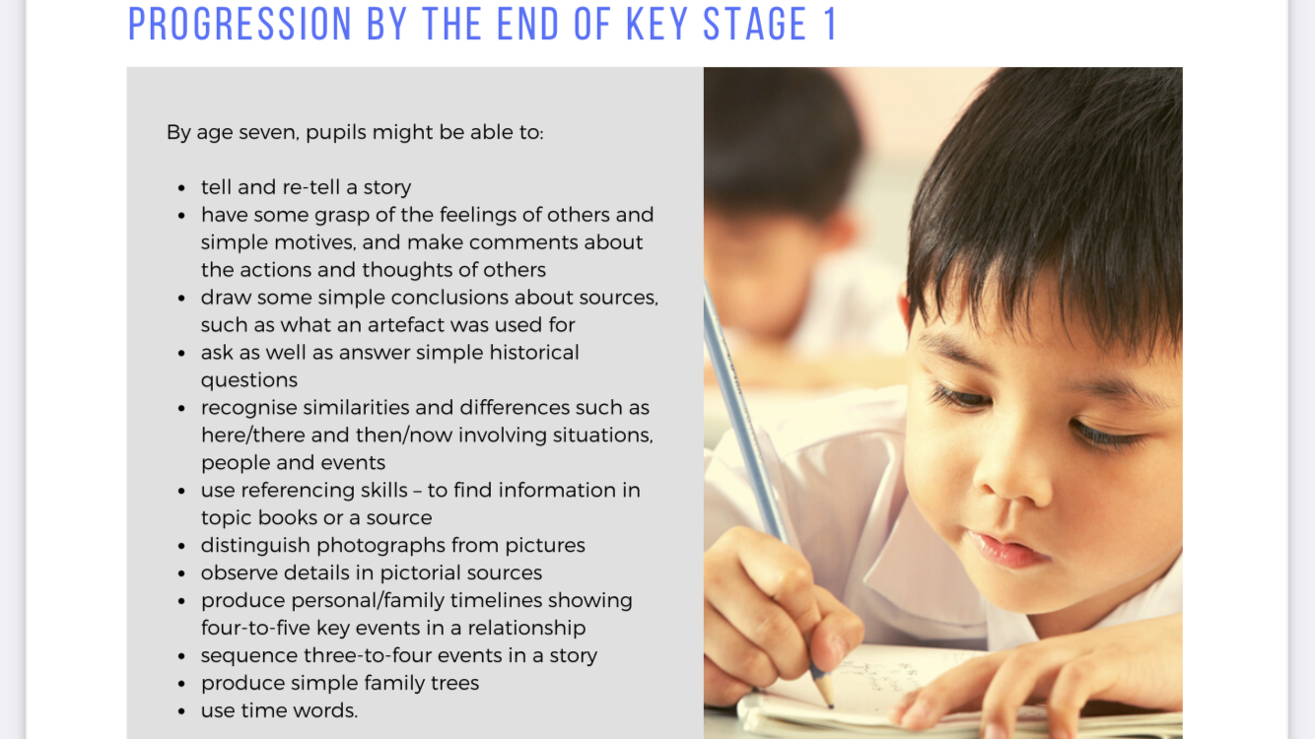

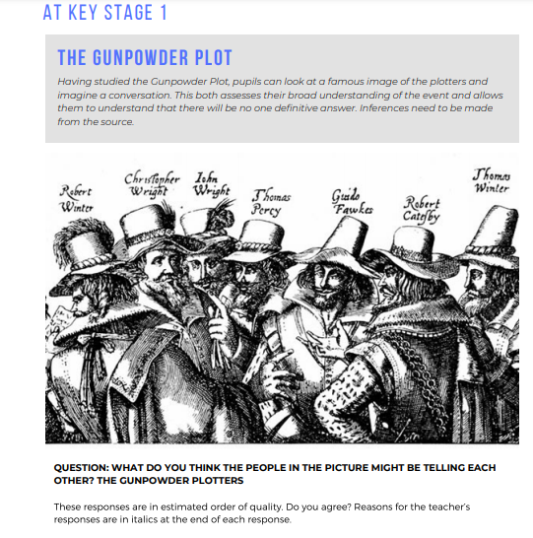
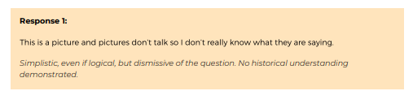
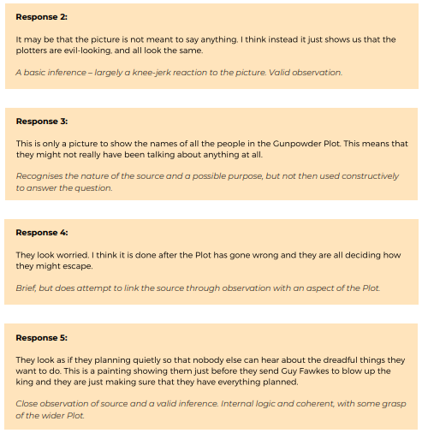

 | Key Concept - Chronological Understanding
Year 3 | Pre-Roman Britain: pupils should be taught about changes in Britain from the Stone Age to the Iron Age  The Stone Age to Iron Age  Local Links: Dartmoor – Merrivale (Neolithic stone rows, circles and Neolithic & bronze age settlements  Kent’s Cavern  Ancient Greece: Pupils should be taught a study of Greek life and achievements and their influence on the western world  Ancient Greece  Use timeline to show children when events took place  Learning Objectives:  - Place (sequence) the time studied on a timeline  - Sequence events or artefacts, understanding that a timeline can be divided into BC and AD (BCE and CE)  - Use dates & vocabulary related to the passing of time
 | Key Concept - Range and Depth of Historical Knowledge
Pre-Roman Britain: pupils should be taught about changes in Britain from the Stone Age to the Iron Age | Substantive Concepts to be covered:  - Trade & Industry (to include trading nationally and internationally)  - Culture & Society (to include immigration – e.g. Beaker Fold)  - Religion & Beliefs  - Invention, Engineering & Discovery (to include metals, tools, fire, the wheel etc)  - Settlements & Homes  - Costume  - Food & Farming
Ancient Greece: Pupils should be taught a study of Greek life and achievements and their influence on the western world | Substantive Concepts to be covered:  - Culture & Society (to include social class, simple introduction to philosophy, medicine, education)  - Leisure & Entertainment (to include sports & Olympics)  - Costume  - Leaders & Monarchy (to include simple politics, democracy, law & order)  - Settlements & Homes  - Religion & Beliefs (linked to architecture)  - Invasion (simple introduction) linked to War, Battles & Weapons and Empire & Colony  - Food & Farming
Key Concept:  Continuity & Change (in & between periods | Learning Objectives:  - To use evidence to find out about everyday lives of people in the period studied and compare with our life today – e.g. culture and leisure activities; clothes, way of life and actions of people of the past; buildings and their uses - sequence, summarize, explain, evaluate, select, identify, categorize, reason, synthesize
Key Concept:  Causes & Consequences | Learning Objectives:  - To Identify reasons for and results of people’s actions - reason/speculate, describe, empathize, explain, summarize, synthesize, evaluate, hypothesize
Key Concept:  Similarities & Differences (within a period/  situation) | Learning Objectives:  - To describe similarities and differences between different periods, e.g. social, religious and ethnic diversity
Key Concept:  Significance (of events/people) | Learning Objectives:  - To identify historically significant people and events in situations  - To study change through the lives of significant individuals - identify, recall, observe, sequence, compare & contrast, reason/speculate, summarize, explain, empathize, reasoned judgement
 | Key Concept - Historical Interpretation
Learning Objectives:

- To explore the idea that there are different accounts of history
- To Distinguish between different sources and evaluate their usefulness

 | Key Concept - Historical Enquiry
Learning Objectives:

- To use documents, printed sources (e.g. archive materials) the internet, pictures, photographs, music, artefacts, historic buildings, visits to museums and galleries and visits to sites as evidence about the past
- To ask questions and find answers about the past, e.g. “How did people…?” “What did people do for…?”
- To suggest sources of evidence to use to help answer questions

 | Key Concept - Organisation & Communication
Learning Objectives:

- To communicate ideas and present findings about the past using different genres of writing; drawing; diagrams; data-handling; drama role-play; re-enactment; storytelling
- To use dates and terms with increasing accuracy in their writing and presentations
- To use IT to achieve the above

 | Vocabulary & unit specific concepts
Use vocabulary and phrases such as:
Tier 1/2: tools, treasure, hunting, trade, art, myths, temples, empire, farming
Tier 3: century, decade, Paleolithic, Mesolithic, Neolithic, Bronze Age, Iron Age, weapons, invasion, settlements, food sources, religion/beliefs, burials, stone rows, stone circles, round houses, Dartmoor, Skara Brae, Stone Henge, megaliths, cremation, excarnation, barrows, cairns, archaeology, hill forts, social class/hierarchy, primary and secondary sources, timeline, chronology, technology/advancements, Greeks, Sparta, Parthenon etc, city states (some of this vocabulary is to be used when revisiting prior learning)

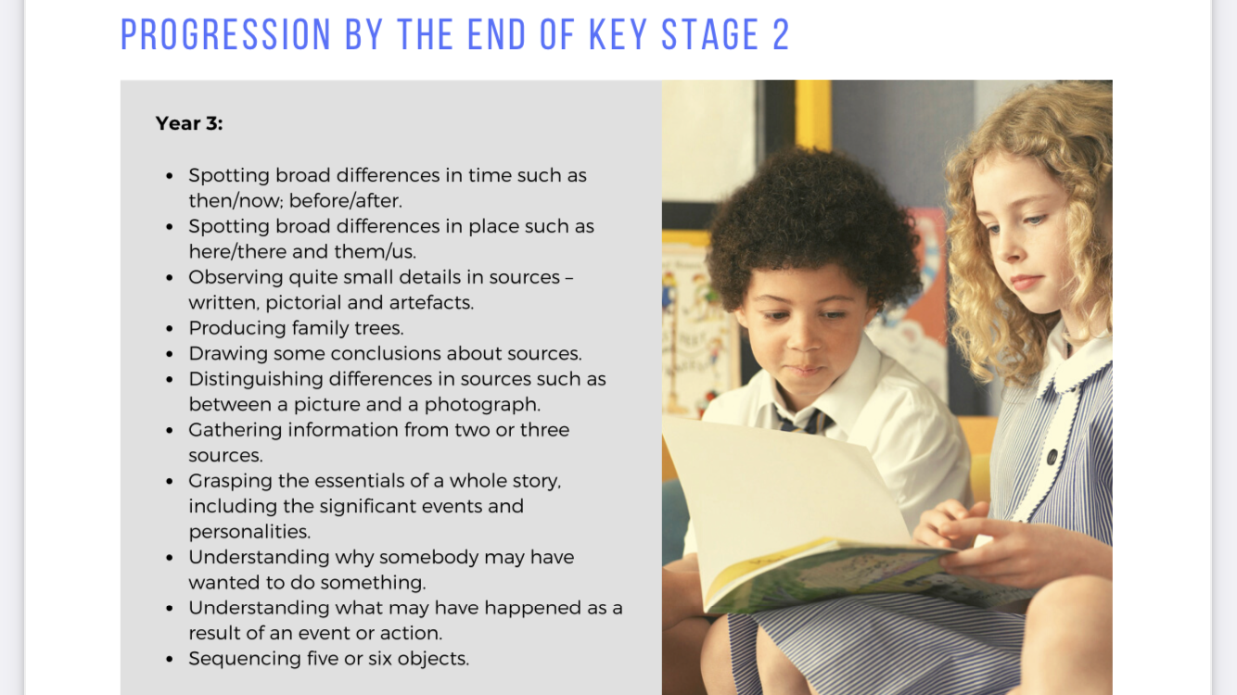

 | Key Concept - Chronological Understanding
Year 4 | Local History: Pupils should be taught about an aspect of local history  The Victorians- Local study  The Victorians and Brunel – atmospheric railway, Paignton Pudding etc  Local Links: Visit station – steam train, trip on a steam train, model railway at Brixham Museum, Torquay Museum, Bygones  Roman Britain: Pupils should be taught about the Roman Empire and its impact on Britain  Roman Britain  What was life like in the Roman period and how was Britain changed? Lasting influence  Local Links: Exeter (Isca) & Exeter Museum & city walls, Exeter Museum, Underground passages  Learning Objectives:  - To place (sequence) events from the period studied on a timeline  - To divide recent history into present, using 21st century and the past, 20th and 19th centuries – recognize, categorize/classify  - To use terms related to the period and begin to date events  - To begin to put names, places and dates of significant events from the past onto a timeline - sequence  - To understand more complex terms and vocabulary (see below)
 | Key Concept - Range and Depth of Historical Knowledge
Roman Britain: Pupils should be taught about the Roman Empire and its impact on Britain | Substantive Concepts to be covered:  - Culture & Society (to include social class & aristocracy)  - Trade & Industry (to include trading nationally and internationally)  - Architecture  - Travel & Transport (to include roads)  - Costume  - Food & Farming  - Invasion  - Leaders & Monarchy (to include law & order)  - Inventions, Engineering & Discovery
Local History: Pupils should be taught about an aspect of local history | Substantive Concepts to be covered:  - Invention, Engineering & Discovery linked to Travel & Transport  - Culture & Society (to include social class)  - Settlements & Homes  - Trade & Industry  - Leisure & Entertainment  - Leaders & Monarchy  - Costume
Key Concept:  Continuity & Change (in & between periods | Learning Objectives:  - To use evidence to demonstrate knowledge and understanding when describing features of past societies and periods - identify, select, recall, reason, categorize, observe, compare & contrast, summarize, synthesize, explain, justify, reasoned judgement, apply, evaluate, critique, informed conclusion  - To Identify and explain change and continuity within and across periods
Key Concept:  Causes & Consequences | Learning Objectives:  - To describe how some of these past events or people from the past affect life today - apply, describe, observe, select, categorize, synthesize, select, explain, compare & contrast, empathize, evaluate, recall, informed conclusion, reason, summarize  - To identify and give reasons for, results of, historical events, situations and changes - apply, describe, observe, select, categorize, synthesize, select, explain, compare & contrast, empathize, evaluate, recall, informed conclusion, reason, summarize
Key Concept:  Similarities & Differences (within a period/  situation) | Learning Objectives:  - To use evidence to show how the lives of rich and poor people from the past differed - apply, describe, observe, select, categorize, synthesize, select, explain, compare & contrast, empathize, evaluate, recall, informed conclusion, reason, summarize  - To identify some ideas, beliefs, attitudes and experiences of men, women and children from the past - apply, describe, observe, select, categorize, synthesize, select, explain, compare & contrast, empathize, evaluate, recall, informed conclusion, reason, summarize  - To describe similarities and differences between people, events and artefacts studied - apply, describe, observe, select, categorize, synthesize, select, explain, compare & contrast, empathize, evaluate, recall, informed conclusion, reason, summarize
Key Concept:  Significance (of events/people) | Learning Objectives:  - To identify historically significant people and events in situations
 | Key Concept - Historical Interpretation
Learning Objectives:
- To look at different versions of the same event in history and identify differences
- To know and understand that people in the past represent events or ideas in a way that persuades others (propaganda)

 | Key Concept - Historical Enquiry
Learning Objectives:
- To use documents, printed sources (e.g. archive materials) the internet, pictures, photographs, music, artefacts, historic buildings, visits to museums or galleries and visits to sites to collect evidence about the past
- To ask questions and find answers about the past e.g. “what was it like for a.… during…?”
- To suggest sources of evidence from a selection provided to help answer questions

 | Key Concept - Organisation & Communication
Learning Objectives:
- To communicate ideas about the past using different genres of writing; drawing; diagrams; data-handling; drama role-play; re-enactment; storytelling
- To discuss the most appropriate way to present information with regard to audience
- Use IT to achieve the above
- Use dates and terms correctly in their writing and presentations

 | Vocabulary & unit specific concepts
Use vocabulary and phrases such as:
Tier 1/2: myths, law, economy, trade, women, transport, war, ships, food, tools, treasure
Tier 3: citizens, , worship, empire, slaves, armies, architecture, archaeology, timeline, chronology, inventions, industry, tourism, education, empire, , medicine, engineering, warfare, fleet, civilization, exploration, monarchy/royalty, siege, defences, social class/hierarchy, servants, battlements, fortification, weapons, primary and secondary sources, century, decade, after, before, during, BC, AD, BCE, CE, after, Victorians, The Modern Era, Roman, invasion, settlements, religion, republic, calendar, technology/advancements, town planning, legacy (some of this vocabulary is to be used when revisiting prior learning)
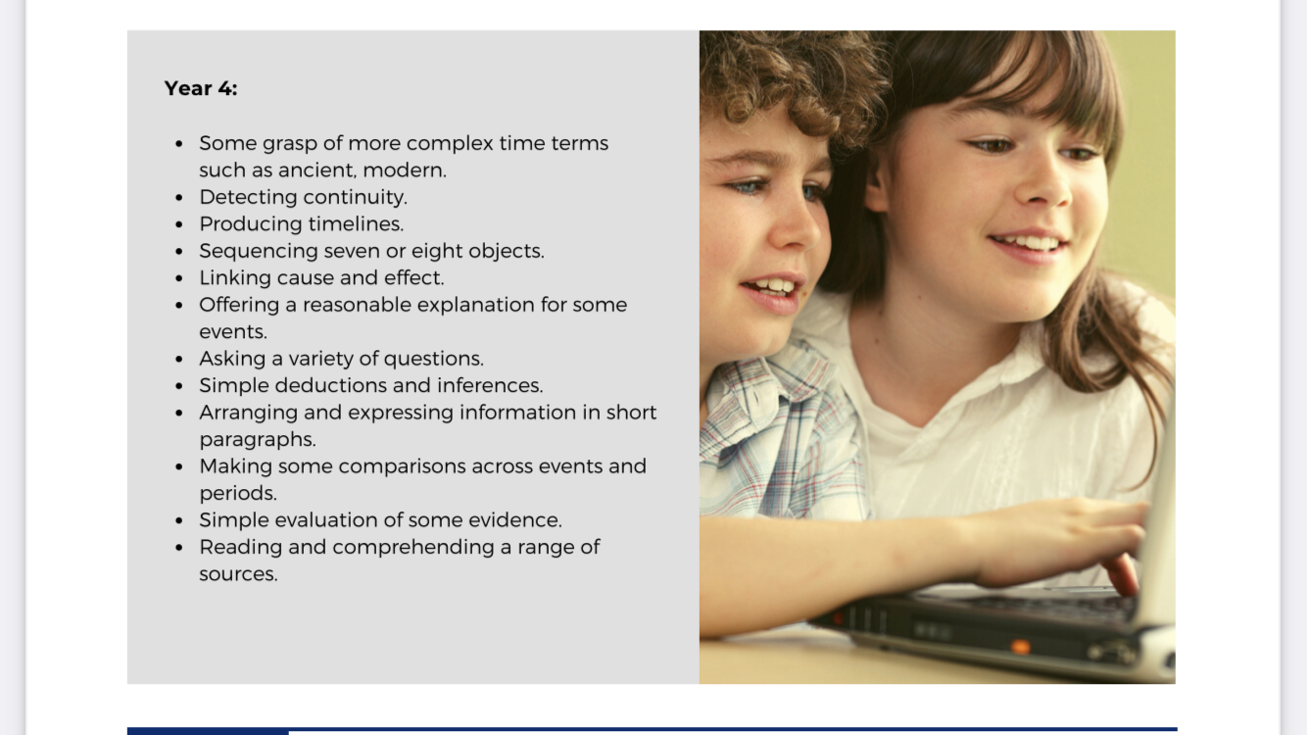
 | Key Concept - Chronological Understanding
Year 5 | Pupils should be able to identify some social, cultural, religious and ethnic diversities of societies studied in Britain and the wider world  Ancient Egypt  Local Links: Torquay Museum Egyptian exhibition  Anglo Saxons & Vikings: Pupils should be taught about the Viking and Anglo-Saxon struggle for the Kingdom of England to the time of Edward the Confessor  Anglo Saxons and Vikings  Use timeline to show children when events took place  Learning Objectives:  - To use timelines to place and sequence local, national and international events  - To know and sequence key events of time studied  - To sequence historical periods  - To use relevant terms and period labels  - To make comparisons between different times in history – identify changes within and across historical periods  - To describe events using vocabulary and phrases as below
 | Key Concept - Range and Depth of Historical Knowledge
Pupils should be able to identify some social, cultural, religious and ethnic diversities of societies studied in Britain and the wider world  Ancient Egypt | Substantive Concepts to be covered:  - Culture & Society (to include social class & aristocracy, art, music etc)  - Invasion  - Invention, Engineering & Discovery (to include pyramids, tombs, statues, hieroglyphs etc)  - Leaders and Monarchy  - Costume  - Empire & Colony  - Religion & Beliefs (to include changes under Akhenaten)  - Food, farming and trade
Anglo Saxons & Vikings: Pupils should be taught about the Viking and Anglo-Saxon struggle for the Kingdom of England to the time of Edward the Confessor | Substantive Concepts to be covered:  - Culture & Society  - Leisure & Entertainment  - Food & Farming  - Costume  - Settlements & Homes  - Travel & Transport  - Invasion linked with War, battles & Weapons  - Trade & Industry  - Religion & Beliefs (include church & state and disagreements – Synod of Whitby)  - Leadership & Monarchy (to include politics, taxation law & order)  - Kingdoms
Key Concept:  Continuity & Change (in & between periods | Learning Objectives:  - To identify changes and links within and across the time periods studied, e.g. religion, houses, society, technology
Key Concept:  Causes & Consequences | Learning Objectives:  - To illustrate some causes and consequences of the main events, situations and changes in the periods studied
Key Concept:  Similarities & Dfferences (within a period/  situation) | Learning Objectives:  - To identify some social, cultural, religious and ethnic diversities of societies studied in Britain and the wider world
Key Concept:  Significance (of events/people) | Learning Objectives:  - To consider the significance of events, people and developments in their context and in the present
 | Key Concept - Historical Interpretation
Learning Objectives:

- To understand that some evidence from the past is propaganda, opinion or misinformation and that this affects interpretations of history
- To give reasons why there may be different accounts of history
- Use a wide range of information to answer questions
- To discuss the effectiveness of sources

 | Key Concept - Historical Enquiry
Learning Objectives:

- To use documents, printed sources (e.g. archive materials) the internet, pictures, photographs, music, artefacts, historic buildings, visits to museums and galleries and visits to sites to collect evidence about the past
- To choose reliable sources of evidence to answer questions, realizing that there is often not a single answer to historical questions
- To investigate own lines of enquiry by posing questions to answer
- To realize that there is often not a single answer to historical questions

 | Key Concept - Organisation & Communication
Learning Objectives:

- To present structured and organized findings to communicate ideas about the past using different genres of writing; drawing; diagrams; data-handling; drama role-play; re-enactment; storytelling
- To use IT to achieve the above
- To use dates and terms accurately
- To plan and present a self-directed project or research about the period studied, choosing the most appropriate format for the intended audience

 | Vocabulary & unit specific concepts
Use vocabulary and phrases such as:
Tier 1/2: farming, tools, treasure, ships, trade, art, writing, battle, raid, defeated
Tier 3: settlements, weapons, invasion, food sources, religion/beliefs/worship, Pagans, Synod of Whitby, Valhalla, myths & legends, Valkyrie, burials, social class/hierarchy, archaeology, runes, Sutton Hoo, architecture, chronology, royalty, armies, conquer, Danegeld, York, kingdoms, monastery, longships, slaughter, pillage, berserker, exiled, Norway, Lindisfarne, Northern Britain – Scotland, timeline, century, decade, primary and secondary sources (some of this vocabulary is to be used when revisiting prior learning)
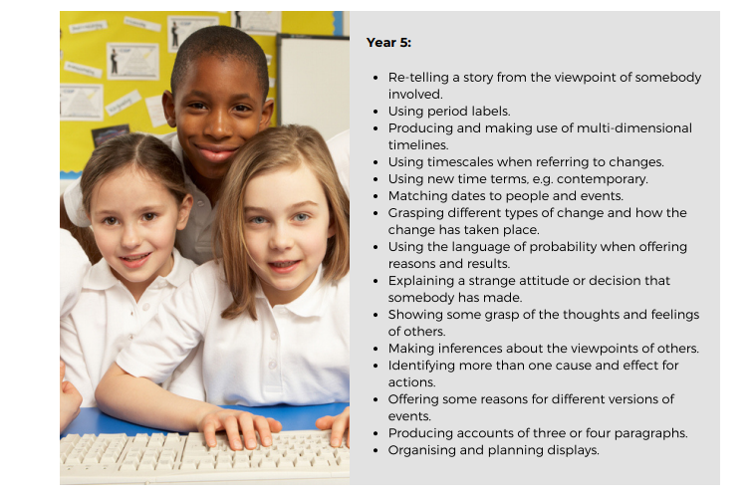

 | Key Concept - Chronological Understanding
Year 6 | Extended chronological study: Pupils should be taught a study of an aspect or theme in British history that extends pupils’ chronological knowledge beyond 1066  WWII  Local Links: Battery Gardens, memorial, Jewish Graveyard, blitzes in Exeter and Plymouth, Slapton Sands  Non-European Study: Pupils should be taught about a non-European society that provides contrasts with British history – one study chosen from: Early Islamic civilization, including a study of Baghdad c. AD 900; Mayan civilization c. AD 900; or Benin (West Africa) c. AD 900 - 1300  Kingdom of Benin  Circa AD 900 – 1300 but to include Benin being ‘absorbed’ into the British Empire in 19th century and the Benin Bronzes (should we be allowed to keep them?)
 | Key Concept - Range and Depth of Historical Knowledge
Extended chronological study: Pupils should be taught a study of an aspect or theme in British history that extends pupils’ chronological knowledge beyond 1066 | Substantive Concepts to be covered:  - Culture & Society (to include social class, rationing, shelters – those that could afford their own and communal shelters, arrival of American troops and black American troops)  - Invasion (to include blitzes and Slapton Sands – D-Day Landings)  - War, Battles & Weapons (to include key battles, borders etc., Battle of Britain, link back to WWI)  - Leaders and Monarchy (to include parliament, politics, propaganda, spies, parties, international leaders, ‘Dig for Victory’ etc Treaty of Versailles, the weakness of the League of Nations and the British policy of appeasement)  - Transport (to include tanks, D-Day landings, Dunkirk etc, aircraft)  - Inventions, Engineering & Discovery (to include Enigma machine – code cracking, Turing, ‘Battleships’ - women plotting U-boats etc, RADAR)  - Religion & Beliefs (to include basic introduction to Nazism as a belief system as well as a political party)  - Costume (to include every day but also military)
Non-European Study: Pupils should be taught about a non-European society that provides contrasts with British history – one study chosen from: Early Islamic civilization, including a study of Baghdad c. AD 900; Mayan civilization c. AD 900; or Benin (West Africa) c. AD 900 - 1300  Kingdom of Benin | Substantive Concepts to be covered:  - Leaders & Monarchy  - Culture & Society (to include social class/hierarchy)  - Settlements & Homes  - Clothes  - Food & Farming  - Leisure & Entertainment  - Invasion (to include the sacking of Benin by the British in C19th)  - Religion & Beliefs
Key Concept:  Continuity & Change (in & between periods | Learning Objectives:  - To Show identified changes on a timeline and know key dates for characters and events of periods studied - select, categorize, sequence, recall  - To make links with some features of past societies, e.g. ancient civilizations
Key Concept:  Causes & Consequences | Learning Objectives:  - To give own reasons why changes may have occurred, backed up with evidence - compare, contrast, recall, reason, summarize, synthesize, explain, empathize, informed conclusion, reasoned judgement, justify, apply, evaluate, critique, hypothesize  - To describe how some changes affect life today
Key Concept:  Similarities & Differences (within a period/situation) | Learning Objectives:  - To select reliable sources of factual evidence to describe: *houses and settlements; culture and leisure activities; clothes, way of life and actions of people; buildings and their uses; people’s beliefs, religion and attitudes; things of importance to people; differences between the lives of the rich and poor  - To compare and contrast between people, events and artefacts studied - observe, categorize, reason, synthesize, explain, informed conclusion, reasoned judgement, justify, apply, evaluate, critique
Key Concept:  Significance (of events/people) | Learning Objectives:  - To consider/explain the significance of events, people and developments in their context and in the present
Key Concept - Historical Interpretation
Learning Objectives:

- To evaluate evidence to choose the most reliable forms
- To consider ways of checking the accuracy of interpretations – fact or fiction and opinion
- To know and understand that people both in the past have a point of view and that this can affect interpretation
- To give clear reasons why there may be different accounts of history, linking this to factual understanding of the past

Key Concept - Historical Enquiry
Learning Objectives:

- To use documents, printed sources (e.g. archive materials) the internet, pictures, photographs, music, artefacts, historic buildings, visits to museums and galleries and visits to sites to collect evidence about the past
- To choose reliable sources of evidence to answer questions, realizing that there is often not a single answer to historical questions
- To investigate own lines of enquiry by posing questions to answer
- To form own opinions about historical events from a range of sources

Key Concept - Organisation & Communication
Learning Objectives:

- To communicate ideas about the past using different genres of writing; drawing; diagrams; data-handling; drama role-play; re-enactment; storytelling
- To plan and present a self-directed project about the period studied or an in-depth study concentrating on one aspect of history, for example, warfare or costume since 1066. This must be presented in an organized and clearly structured way with awareness of the intended audience
- To make accurate use of specific dates and terms
- To use IT to achieve the above

 | Vocabulary & unit specific concepts
Use vocabulary and phrases such as:
Tier 1/2: transport, communication, medicine, borders, navy, engineering
Tier 3: soldiers, primary and secondary sources, technology, inventions, education, kingdom, chiefs, officials, warriors, astronomy, calendars, literature, aristocracy, servants, empire, merchants, rainforest, palaces, temples, agriculture, industry, courts, religion/beliefs, blitzes, bombings, Slapton, Operation Tiger etc, civilization, soldiers, skirmishes, military clothing, fleets, transport, parliament, air fleet, continent, military, propaganda, uniforms, rebellion, siege, defences, factories, land army, air-raid shelters, air-raids, black-outs, evacuees, segregation, treaties, legacy (some of this vocabulary is to be used when revisiting prior learning)

