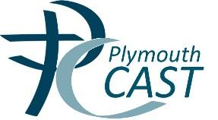

Pupil Premium Strategy Statement
Expenditure Evaluation
Strategy Plan
2023-26
“I was disadvantaged as a child, yet I had the advantage of being in the company of great teachers.”
(A.P.J. Abdul Khan, 11th President of India)
“Every one of our children is carrying something the world is waiting for – it’s just the world hasn’t got it yet,” Sister Judith Russi
The ‘Pupil Premium’ is a government initiative that provides extra funding aimed at pupils from disadvantaged backgrounds. Research shows that pupils from deprived backgrounds underachieve compared to their peers and that there is a strong link between eligibility for free school meals and underachievement. The Pupil Premium is designed to help each school boost the attainment of disadvantaged children and reduce the gap between the highest and the lowest achievers. The government has used pupils’ entitlement to free school meals (FSM) and children looked after by the local authority (CLA) as an indicator for deprivation. The funding is allocated according to the number of pupils on roll who have been eligible for free school meals at any point in the last 6 years (known as ‘Ever6 FSM’), an allocation for each pupil who has been ‘Looked After’ (in care) and a smaller amount for the children of service families.
Principles
- To ensure that teaching and learning opportunities meet the needs of all pupils.
- To ensure that appropriate provision is made for pupils who belong to vulnerable groups, this includes ensuring that the needs of socially disadvantaged pupils are adequately assessed and addressed.
- In making provision for socially disadvantaged pupils, we recognise that not all pupils who receive free school meals will be socially disadvantaged.
- We also recognise that not all pupils who are socially disadvantaged are registered for free school meals. We reserve the right to allocate the Pupil Premium funding to support any pupil, or groups of pupils the schools have legitimately identified as being socially disadvantaged.
- Pupil Premium funding will be allocated following a needs analysis which will identify priority groups or individuals. Limited funding and resources means that not all children receiving free school meals will be in receipt of pupil premium interventions at one time.

Pupil premium strategy statement
Before completing this template, you should read the using pupil premium guide and the appropriate example statement available on the pupil premium page.
Before publishing your completed statement, you should delete the instructions (text in italics) in this template, including this text box.

This statement details our school’s use of pupil premium (and recovery premium for the 2023 to 2024 academic year) funding to help improve the attainment of our disadvantaged pupils.

It outlines our pupil premium strategy, how we intend to spend the funding in this academic year and the effect that last year’s spending of pupil premium had within our school.

School overview
Detail | Data
School name | Sacred Heart
Number of pupils in school | 22-23: 206
Proportion (%) of pupil premium eligible pupils | 23-24: 28%
Academic year/years that our current pupil premium strategy plan covers (3 year plans are recommended) | 2021-24
Date this statement was published | 3-year plan: September 21
Date on which it will be reviewed | October 23
Statement authorised by | Jo Flower
Pupil premium lead | Nichola Day
Governor / Trustee lead | Julie Burnard
Funding overview
Detail | Amount
Pupil premium funding allocation this academic year | £69,747
Recovery premium funding allocation this academic year | £8,990
Pupil premium funding carried forward from previous years (enter £0 if not applicable) | £0
Total budget for this academic year  If your school is an academy in a trust that pools this funding, state the amount available to your school this academic year | £78, 737

Part A: Pupil premium strategy plan

Statement of intent
Our intention is that all pupils make good progress and achieve high attainment across all subject areas. The focus for our pupil premium strategy is to support disadvantaged pupils to achieve that goal, including progress for those who are already high achievers.
High-quality teaching and bespoke pastoral support are at the heart of our approach, with a focus on areas in which disadvantaged pupils require the most support – oracy, reading and pastoral care. This is proven to have the greatest impact on closing the disadvantaged attainment gap and at the same time benefit the non-disadvantaged children in our school. Implicit in the intended outcomes detailed below, is the intention that non-disadvantaged pupils’ attainment will be sustained and improved alongside process for their disadvantaged peers. Our approach will be responsive to the common challenges and individual needs, rooted in robust diagnostic assessment. Common barriers to learning for disadvantaged children, can be less capacity for support at home, poor language and communication skills; lack of confidence and self-esteem; difficulties with learning behaviours and attendance and punctuality issues. There may also be complex family situations that prevent children from flourishing. The challenges are varied and there is no “one size fits all”.
Sacred Heart’s ultimate objectives for your disadvantaged pupils
- To remove the attainment gap between disadvantaged and non-disadvantaged pupils.
- To support pupil’s physical and emotional health and wellbeing to enable them to access their learning.
- For all disadvantaged pupils to achieve at least national expectations in reading, writing and maths.
- Equity of access to all areas of the curriculum including wider school opportunities for disadvantaged pupils.

We aim to do this through:
- High expectations and high experiences for all.
- Assessment not assumption. Finding the areas of need for our community, cohort and individuals
- Ensuring high quality teaching and learning in every class which meet the needs
of all pupils.
- Quality interactions between adults and pupils throughout the day, adopting a whole school approach in which staff take responsibility for disadvantaged pupils’ outcomes and raise expectations of what they can achieve through positive relationships.
- Acting early to intervene at the point need is identified.
- High quality pastoral care for both our children and their families.
This list is not exhaustive and will change according to the needs and support our socially disadvantaged pupils require.
- Teachers and support staff know their children. Quality transitions and open communication with parents
- Weekly cover for class teachers to work 1:1 and in small groups with identified children on bespoke targets.
- Teaching assistant support in every class.
- Bespoke intervention programmes to address individual gaps, supporting rapid
catch-up.
- Provide financial support for extra-curricular activities e.g, educational visits and residentials ensuring children have first-hand experiences to draw upon to support in their learning in the classroom.
- Development of ’11 before 11’ across thew curriculum to increase social and cultural capital.
- Systematic monitoring of attendance and bespoke support for families through a Family Support Worker and Attendance Officer.
- Increase provision within the school’s pastoral team to support children’s social
and emotional learning/ELSA training for all TAs.
- Opportunities for the children to learn a musical instrument and to sing in an award-winning choir in community settings.
- Behaviour and nurture support during lunchtimes by providing activities to engage and promote Gospel values and thus enhance learning.
- Transition support into school every morning for identified pupils.
- Bespoke ‘Diverse’ group using physical education as a way in for individual meeting needs in learning behaviours.

Challenges
This details the key challenges to achievement that we have identified among our disadvantaged pupils.
Challenge number | Detail of challenge
1 | Low attainment on entry to the Early Years Foundation Stage (Nursery) in all areas, particularly PSED, CL and PD.
2 | Assessments and observations indicate that the education and well-being of many of our disadvantaged pupils have been impacted by school closures to a greater extent than for other pupils. These findings are supported by national studies. This has resulted in significant knowledge gaps leading to pupils falling further behind age-related expectations, particularly in maths and writing.
3 | Increase in the number of pupils with multiple disadvantages.
4 | Assessments, observations and discussions with pupils indicate under-developed oral language skills and vocabulary gaps among many disadvantaged pupils, particularly in EYFS/KS1.
5 | Due to staffing, there is a lack of a variety of extra-curricular clubs for disadvantaged children for their personal development.
6 | Attendance – attendance amongst disadvantaged pupils is presently lower than for non-disadvantaged pupils and lower than the national attendance ‘all’ pupils.

Activity in this academic year
This details how we intend to spend our pupil premium (and recovery premium funding) this academic year to address the challenges listed above.

Intended outcomes
This explains the outcomes we are aiming for by the end of our current strategy plan, and how we will measure whether they have been achieved.
Intended outcome | Success criteria
To remove the attainment gap by the end of Reception | All disadvantaged pupils in line with their non-disadvantaged peers
Increase % of EYFS pupils achieving GLD in reading, writing and maths. | Disadvantaged pupils achieving GLD is at least in line with their peers.
Increase % of Year 1 (Year 2) pupils achieving the Phonics Screening threshold. | Disadvantaged pupils meeting the expected standard in phonics in year 1 (year 2) is at least in line with their peers.
All pupils make at least expected progress in reading, writing and maths by the end of KS1 | Pupils eligible for PPG make more progress than their peers to remove the attainment gap.
Increase the number of pupils achieving the expected standard in reading, writing and maths combined at the end of KS1 | Pupils in receipt of PPG achieving the expected standard in reading, writing and maths combined at the end of KS1 is in line with their peer
Increase the number of pupils achieving at Greater Depth in reading, writing and maths combined at the end of KS1 | Pupils in receipt of PPG achieving the higher standard in reading, writing and maths combined at the end of KS1 is in line with their peers
All pupils make at least expected progress in reading, writing and maths by end of KS2 | Progress of PP pupils matches or exceeds progress of non-PP pupils
Increase the number of pupils achieving the expected standard in reading, writing and maths combined at the end of KS2 | Pupils in receipt of PPG achieving the expected standard in reading, writing and maths combined at the end of KS2 is in line with their peers
Increase attendance of disadvantaged pupils | Attendance of identified pupils increases and the gap between non-disadvantaged pupils and disadvantaged pupils is removed – attendance of disadvantaged pupils is above 96%
Reduce the number of disadvantaged pupils with persistence absence from school (below 90%) | The overall attendance figure is above 96% and there is no attendance gap between disadvantaged children and non-disadvantaged peers.
Pupils fully engaged with all aspects of school-life | Pupil surveys (including aspirations) reflect enjoyment in school, increased participation and improved attitudes to learning. Attendance increases (see attendance target above).
To achieve and sustain improved well-being for all pupils in our school, particularly for our disadvantaged pupils. | Sustained high levels demonstrated by: • Qualitative data from student voice, student and parent surveys and teacher observations  • A significant increase in participation in enrichment activities, particularly among disadvantaged pupils  • Vulnerable families identified have access to required emotional and well-being support

Activity in this academic year
This details how we intend to spend our pupil premium (and recovery premium funding) this academic year to address the challenges listed above.

Teaching (for example, CPD, recruitment and retention)
Budgeted cost: £25,950
Activity | Evidence that supports this approach | Challenge number(s) addressed
High quality CPD in English, maths, and foundation subjects for all staff.  We are part of SWIFT, Torbay English and Maths Hub and Plymouth CASTs subject leader networks. A full CPD programme is in place for all teaching staff.  Supply for attendance of SLs each half term:  English: £1200  Maths: £1200  Science: £1200  RE: £600  FS: £2000  (£6200)  Bi-weekly support staff meetings to be led by Pastoral Lead and Deputy SENCO  £2500  Bi-Weekly support staff training in RWI + portal (funded elsewhere)  £2500  Identified subjects for improvement:  Science (PSQM) - £600 + 5 days supply £1000  Resourcing: £1000  DT – 4 days supply - £800  Resourcing: £500  PE – L5 PE Leaders CPD £1000 | There is a strong evidence base that high-quality teaching, developed by CPD is a top priority.  High quality staff CPD is essential to follow EEF principles.  Continued use of NPQ programmes for targeted staff and full, committed engagement with ECT programme through Teach First.  Effective Professional Development | EEF (educationendowmentfoundation.org.uk) | 1,2,4
High quality CPD in Relational Trauma for all staff.  Further TIS UK training to ensure high quality relationships.  Team Teach updates for new staff  £2200 | Improving Behaviour in Schools | EEF (educationendowmentfoundation.org.uk)  Evidence Base (traumainformedschools.co.uk)  Impact (traumainformedschools.co.uk)
Continue to embed dialogic interventions across the school including taking part in Plymouth Oracy project  3 days supply for monitoring - £600  Talk Boost Training for all TAs and purchasing materials.  £2000  Picture News subscription & CPD £300 | There is a strong evidence base that suggests oral language interventions, including dialogic activities such as high-quality classroom discussion, are inexpensive to implement with high impacts on reading:  Oral language interventions | EEF (educationendowmentfoundation.org.uk)  Poor Language and Communication skills on entry to nursery. Most children are working in the 22-36 month age band and are unlikely to have the breadth of vocabulary that reflects their experiences on entry to Reception. In KS1 and KS2, children are unlikely to use talk to connect ideas and explain what is happening coherently Higher than average numbers of children access SALT in Reception – a large proportion of disadvantaged children access and will either require small group support or 1:1 support from speech and language with an assigned to TA to support.  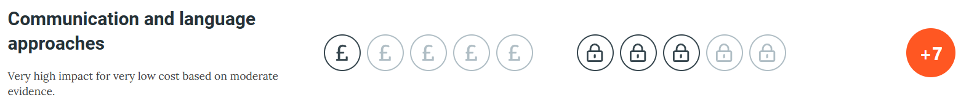  +7 months in Eys. | 1, 2, 4
Enhanced training and monitoring programme for new staff by RWI manager 1 x 1hr weekly for observation, coaching and CPD  Phonics Lead x 38  £950 | Phonics approaches have a strong evidence base that indicates a positive impact on the accuracy of word reading (though not necessarily comprehension), particularly for disadvantaged pupils:  Phonics | EEF (educationendowmentfoundation.org.uk) | 1,2
Enhancement of our teaching of reading and curriculum planning in line with DfE and EEF guidance. We will fund teacher release time to embed key elements of guidance in school.  Reading Lead 1 x PM x 19 week (£1,900) | 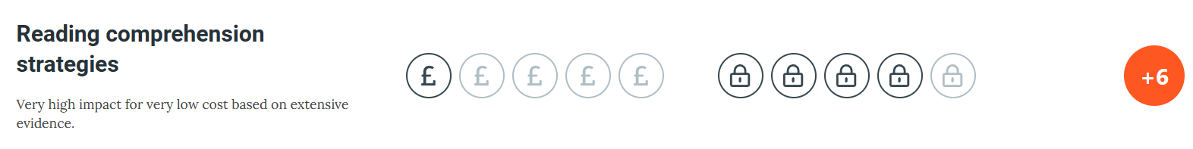  Highest impact on EEF research. Extensive evidence. SL monitoring the impact of reading lessons (comprehension) and coaching and mentoring teachers.
Enhancement of our Maths teaching and curriculum planning in line with DfE and EEF guidance. We will fund teacher release time to embed key elements of guidance in school  Teacher: 1 x PM x 38  £1,900 | The EEF guidance is based on a range of the best available evidence:  Improving Mathematics in Key Stages 2 and 3 | EEF (educationendowmentfoundation.org.uk)  Improving Mathematics in the Early Years and Key Stage 1 | EEF (educationendowmentfoundation.org.uk)  +7 months  Mastering Number | NCETM | 1,2

Targeted academic support (for example, tutoring, one-to-one support structured interventions)
Budgeted cost: £25,787 + £8000 recovery
Activity | Evidence that supports this approach | Challenge number(s) addressed
Additional teacher 5 x PMs to release class teachers to work with targeted pupils (maths)  5 x PM x 38  £8,000 | The EEF guidance is based on a range of the best available evidence:  Improving Mathematics in Key Stages 2 and 3 | EEF (educationendowmentfoundation.org.uk)  Small group tuition | EEF (educationendowmentfoundation.org.uk) | 1,2,4
Reading, writing and maths intervention programmes and in class adult group support to close gap and increase progress/attainment of disadvantaged pupils. This will include training time and delivery time for teaching assistants.  55 TA hrs weekly x 38  £21, 945  (see HN re: oncosts) | Tuition targeted at specific needs and knowledge gaps can be an effective method to support low attaining pupils or those falling behind, in small groups:  Small group tuition | EEF (educationendowmentfoundation.org.uk) | 1,2,4
Additional phonics sessions targeted at disadvantaged pupils who require further phonics support.  PM x 12 x 3  £684 | Synthetic phonics approaches have a strong evidence base indicating a positive impact on pupils, particularly from disadvantaged backgrounds. Targeted phonics interventions have been shown to be more effective when delivered as regular sessions over a period up to 12 weeks:  Phonics | EEF (educationendowmentfoundation.org.uk)  On entry to Reception, many PP children have low Language and Communication skills – 90% of disadvantaged children are working in the low 30-50/ 22-36 month age band with 43% of disadvantaged children working significantly below in 16-26/ 22-36 month age band. Due to and poor socio-economic and disadvantaged upbringing, children are unlikely to have the breadth of vocabulary, knowledge and skills required that ‘typical’ Reception children have. In KS1 and KS2, children are unlikely to use talk to connect ideas and explain what is happening coherently. 24% of disadvantaged children have significant SEND/ learning difficulties requiring high levels of care, 3 of those with additional medical and intimate care needs Most children working within 16-26/22-36 month age band on entry to Reception despite making accelerated progress, do not meet the required end of year ELG’s. The additional teaching staff sees progress accelerated in KS2 where Disadvantaged Children’s results outperform ‘others.’  EEF (+6) Very high impact for relatively low cost ‘Overall, studies of oral language interventions consistently show positive impact on learning, including on oral language skills and reading comprehension. On average, pupils who participate in oral language interventions make approximately five months' additional progress over the course of a year. NELI – to implement language intervention to improve listening, narrative and vocabulary development. | 1,2,4
Times Table Rockstars (£176)  Numbots (£94) | Increasing trajectory in Y4 maths data  Average: 2019:17 2020: 19.5 2021: 22 2022:23 | 2, 4
Talk Boost  PM x 38 x 3  £2166  Staffing SALT support  1 x PM TA x 38  £722 | Evidence for the early years | EEF (educationendowmentfoundation.org.uk)  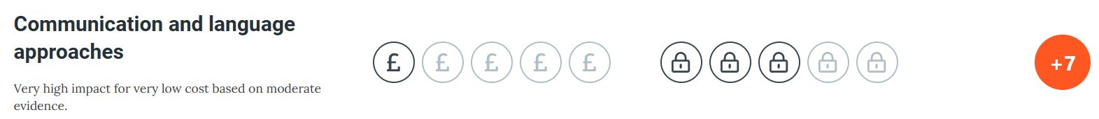

Wider strategies (for example, related to attendance, behaviour, wellbeing)
Budgeted cost: £18,7995
Activity | Evidence that supports this approach | Challenge number(s) addressed
Subsidising trips, clubs and musical tuition  £2000 | Enrichment activities will have a positive knock-on effect on attendance rates and cultural capital.  Boost wellbeing, attendance and future aspirations.  Places funded in EC clubs for targeted vulnerable pupils.  Education Endowment Foundation | EEF | 5
Play Therapy for children with significant SEMH needs.  £9,500 | Supports children’s SEMH needs to allow them to access the full curriculum to progress learning  Improving Social and Emotional Learning in Primary Schools | EEF (educationendowmentfoundation.org.uk) | 5
Systematic monitoring of attendance  Bespoke support for families through a Family Support Worker and Attendance Officer.  SWFV SLA  £14,000 | Working together to improve school attendance (publishing.service.gov.uk)  Behaviour interventions | EEF (educationendowmentfoundation.org.uk)  Improving Social and Emotional Learning in Primary Schools | EEF (educationendowmentfoundation.org.uk) | 6
Increase provision within the school’s pastoral team to support children’s social and emotional learning through ELSA. Second wave of ELSA training for TAs.  1 TA PM x 4  £3192 | EF - ‘Interventions which target social and emotional learning (SEL) seek to improve pupils’ interaction with others and self-management of emotions, rather than focusing directly on the academic or cognitive elements of learning. SEL interventions might focus on the ways in which students work with (and alongside) their peers, teachers, family or community.  School staff need to provide significant pastoral support to identified pupils due to impact of national lockdown. Children are settled in the school with effective support emotionally and socially in order to access learning and to have safe, cooperative playtimes. Our pastoral team provide a range of interventions for families and pupils to ensure we are meeting the needs of the whole child. These interventions are fluid in their approach. | 3
Behaviour and nurture support during lunchtimes  1hr x 5 x 38  £1,710 | Improving Social and Emotional Learning in Primary Schools | EEF (educationendowmentfoundation.org.uk)
Transition support into school every morning for identified pupils.  30 minutes daily x 5 x 38  £997.50 | Improving Social and Emotional Learning in Primary Schools | EEF (educationendowmentfoundation.org.uk)

Total budgeted cost: £77,000

Part B: Review of outcomes in the previous academic year

Pupil premium strategy outcomes
This details the impact that our pupil premium activity had on pupils in the 2021 to 2022 and 2022-2023 academic year.
Review: Year One (21-22)
Although still a significant gap, there is improvement on 2020: 0% (0/6) and 2021: 25% (1/4) showing the early interventions are having impact on some pupils.
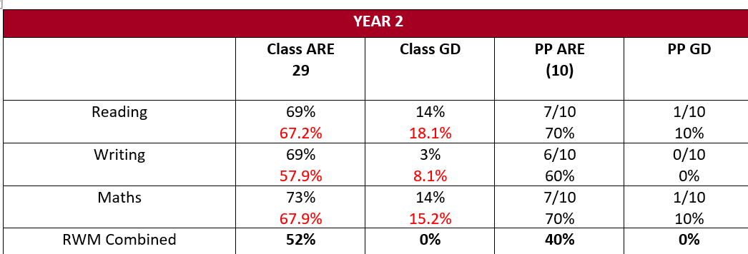

PP results are broadly in line with national averages for all children at ARE. The three PP pupils not reaching ARE have multiple disadvantages including SEND.

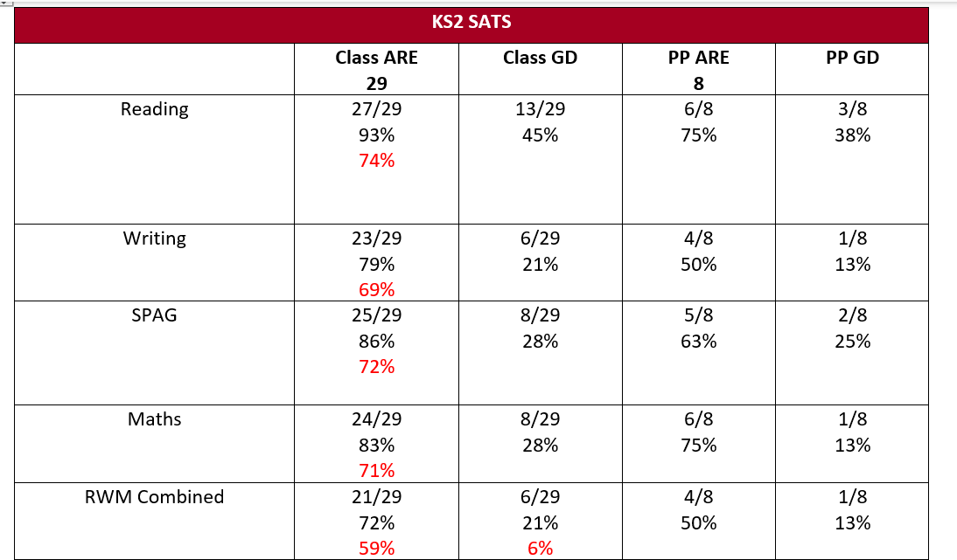
PP is above the national average for all pupils in Reading and Maths.
Progress across KS2
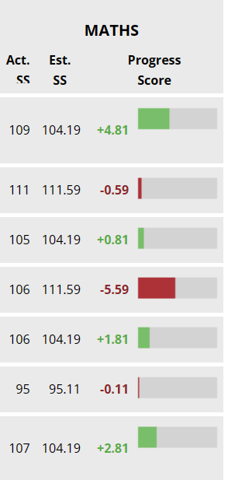
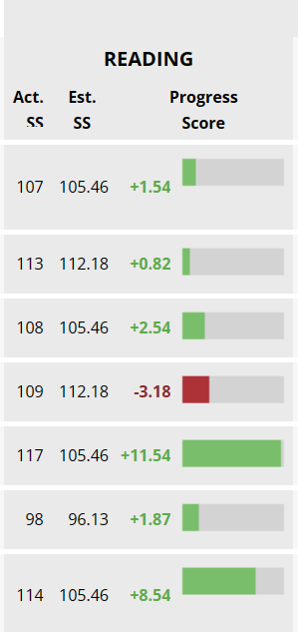
1 pupil who sat the tests a week later on an amended timetable due to covid illness did not make the expected progress from KS1.
7/8 PP pupils made more than their targeted progress in reading. 6/8 in maths.

Teaching
Class teachers leading the tutoring sessions has been the most impactful intervention to date. Data shows that the majority of targeted PP children in Y345 caught or kept up. All targeted PP children in Y2 and Y6 achieved at least ARE. Those who did not are on track for the end of KS2 if continuing their progress at their present trajectory.
Targeted Academic Support
Pre-teaching maths sessions and precision teaching of CEW and tables have also proven to be highly effective interventions.
Wider Strategies
Play Therapy: Over the year, 12 children have accessed weekly 1:1 therapy. 3 were Y6 leavers, 2/3 reaching RWMC and the other in a regulated position to begin her secondary education. 2 further children ended the programme successfully, one at ARE and one now accessing his learning in class on a daily basis and beginning to make progress. 3 pupils have moved to different schools and 4 remain in sessions for 22-23.
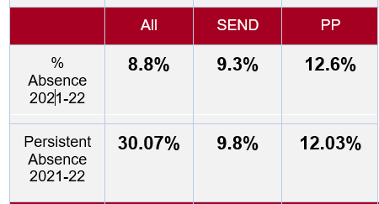
Attendance
PP pupils remain below national for attendance. The data is significantly altered by the persistent absences of some PP individuals. Case studies are available. Data on individual PA successes also available.

Review Year 2 (2022-2023)
GLD
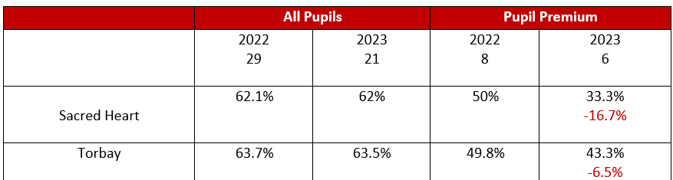
Less than 10% below Torbay’s average but Sacred Heart’s percentage of PP pupils was considerably higher than Torbay’s average. SH: 28.6% Torbay 18.7%
2/6 PP pupils achieved GLD. The remaining 4/6 have multiple disadvantages.
Despite the GLD remaining low, RW&M has increased form previous years. The introduction of Mastering number has had a positive impact on early maths understanding. More pupils reached ELG in number this year than in previous years.
Phonics
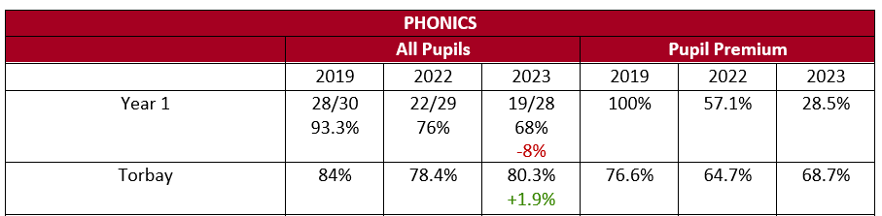
The 5/7 PP pupils will receive further intensive 1:1 phonics into Y2. There was much turbulence in staffing in the Autumn term of 2022. The Y1 teacher went on maternity in Nov 22 and we were unable to recruit a suitable replacement. There was a succession of agency staff until Feb 23, many who were not experienced in RWI. A permanent and experienced Y1 teacher took up position in Feb 23.
Progress between Feb 23 and June 23 was rapid. All PP pupils made accelerated progress during this time but not enough to reach the 32 threshold. This was due to strong leadership from the new phonics lead (agreed by Ofsted May 23), improved weekly coaching and mentoring sessions, bespoke CPD on the RWI portal; permanent teacher in Y1 experienced in RWI showing fidelity to RWI; redeployment of experienced TA taught the 1:1 sessions in Y1/2.
KS1
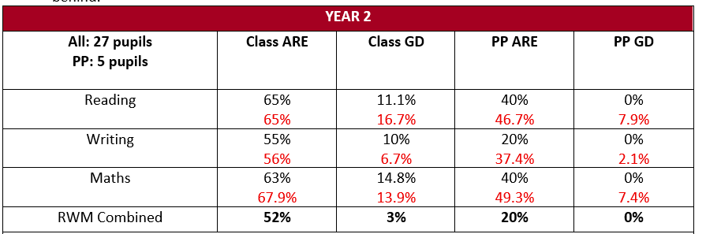
There was much disruption with staffing in the Autumn term in this high-needs class. Research shows that disadvantaged children are more likely to be affected by disruptive behaviours as they lack the protective factors that non-disadvantaged will probably have. This cohort has been the most affected by covid due to missing their formative years in EYFS.
When this cohort was in Reception the percentage of PP pupils reaching GLD was 0%. We have increased this by 40% in reading and maths and 20% in writing.
Staffing deployed for Y3 with two experienced staff members with proven ‘good’ teaching and two additional school funded TAs for support with learning behaviours.
MTC
50% (3/6) got 25/25 – national =
Average of the 6 PP pupils was – 23.6% National average for all pupils =
TT Rockstars, in class quality first teaching and an after school tables club for those needing homework support led to above average results for all pupils, including disadvantaged.
KS2
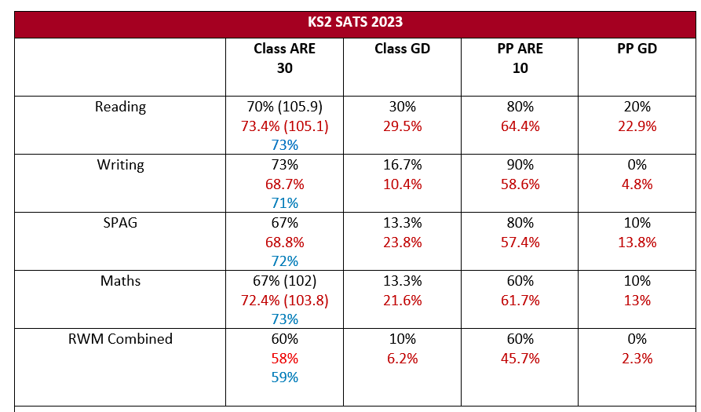
Much to celebrate for PP in R, W and GPS. Quality reading lessons by KS2 teachers are allowing all pupils to access learning. Improvements in oracy, vocabulary and comprehension are evident in the percentage of PP pupils (a third of this cohort) who achieved better than the national average for all pupils.
Reading +7% higher than national average for all pupils
Writing +19% higher than the national average for all pupils
GPS +18% higher than the national average for all pupils
Teaching
Class teachers leading the tutoring sessions has been the most impactful intervention to date. Data shows that the majority of targeted PP children in Y345 caught or kept up with very successful results in Y6.
Y5: 86% (6/7) of PP pupils achieving RWMC.
Y4: 67% (4/6) of PP pupils achieving RWMC.
Y3: 67% 6/9 of PP pupils achieving RWMC. 11% GD RWMC
Y2: 33% 2/6 of PP pupils achieving RWMC
Y1: 33% (3/9) of PP pupils achieving RWMC
YR: 63% (5/8) pupils achieving RWMC.
Targeted Academic Support
Pre-teaching maths sessions and precision teaching of CEW and tables have proven to be the most highly effective interventions along with class teachers running 1:1 and small group catch up sessions weekly.
Wider Strategies
Play Therapy:
We have begin to target pupils into Play Therapy in EYFS/KS1 for early intervention. The sessions are for shorter periods and we are seeing more impact on learning behaviours.
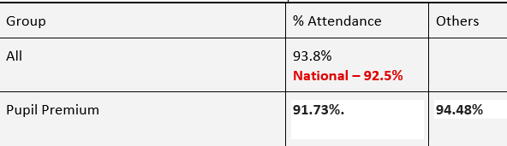
Attendance for 22-23
PP attendance for 21-22 was 87.4% so considerable improvements have been made this year (+4.33%).However it remains below national for whole school attendance (92.5%) by 0.77%. The data is significantly altered by the persistent absences of some PP individuals. Case studies are available. Data on individual PA successes also available.

Externally provided programmes
Please include the names of any non-DfE programmes that you purchased in the previous academic year. This will help the Department for Education identify which ones are popular in England
Programme | Provider
Read, Write, Inc | Oxford Press
Power Maths | Pearson/White Rose
Accelerated Reader | Renaissance Learning

